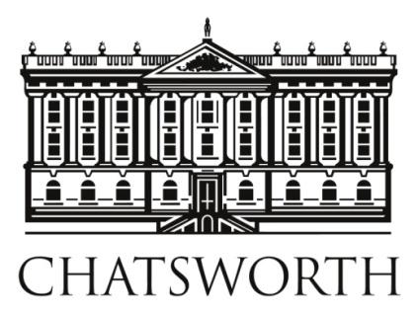
Press facilities – are provided by The Chatsworth International Horse Trials 2024 - for the use of accredited journalists and photographers only.
Please contact the Media Officer: Rachael Y. Morley – Tel: 07889 083194
or email: morley274@btinternet.com

Media Resources

Terms & Conditions – Media Accreditation

PHOTOGRAPHERS
1. Only photographers who have a commission from a bona fide publication (print &/or digital) will be considered for accreditation. The publication, commissioning editor, email address and phone number must be included on the accreditation application form and they may be contacted by Chatsworth. Samples of published work may be requested.
2. Only one photographer will be accredited per publication per day and no assistants are permitted.
3. All photographers must carry full Public Liability and Third Party Liability insurance and by accepting these conditions indemnify the owners and managers of the Chatsworth Estate and the Horse Trials against all costs claims and other expenses that they may incur from any third party. Evidence of such insurance must be available and produced on request during the Event.
4. Only the officially appointed event photographers may sell images of the competitors or the competition to competitors, owners &/or the public within three months of the competition.
5. Accreditation numbers are limited and all applications will be decided by the Event Director or her nominee(s). Previous accreditation is no guarantee of a repeat in 2015 or in the future.
6. Badges/bibs will be issued on arrival at the Media Centre
7. Show jumping - access to the arena will be limited and only those granted such access will be permitted to remain in the arena to cover the presentations. Other photographers may be given space/seats at the side of the arena but must remain sitting down and avoid obstructing the view of the public.
8. Complimentary high res images for publication of all phases of the competition and presentations will be available in the media section of the Chatsworth website.
9. All accredited media must comply with the requests and instructions of the event Organisers and stewards.
10. Submission of the accreditation form confirms acceptance of these Terms and Conditions.
11. Any photographer in breach of these conditions will have his accreditation cancelled, be asked to leave the grounds and will not be accredited in future.

TV/FILM CREWS (Including Web Cameramen)
1. Anyone wishing to film or otherwise acquire moving pictures by any means available now or in the future must outline their production plan / synopsis to the Chatsworth Media Officer prior to applying for accreditation. Accreditation is entirely at the discretion of the Event Director &/or her nominee(s)/Chatsworth House Trust.
2. Filming may only take place in locations agreed by the Chatsworth Media Officer.
3. TV Filming etc – please contact the Chatsworth Media Officer
4. Film Crews must carry full Public Liability and Third Party insurance for all activities on the Chatsworth Estate. They must indemnify the owners and managers of the estate and the Horse Trials against all costs, claims and other expenses that they may incur from any third party. Evidence of insurance must be available and produced on demand during the event.
5. Any film or images are only to be used for the purposes agreed in advance. Under no circumstances may any material be used for any other commercial purposes, e.g. promotion or advertising by those filming or any third party, without specific consent in writing, which will only be granted on payment of (additional) fees to be agreed.
6. Those filming are responsible for making good any damage to any property on the Estate at their own expense.
7. All equipment will be provided by the crew.
8. An accreditation to film may not be assigned or otherwise passed on or shared with any third party.
9. All relevant UK legislation must be observed, including Health and Safety Legislation.
10. A fee plus VAT (to be agreed case by case) will be charged, payable prior to the start of filming, except in the case of ‘news coverage’ where no fee will be charged.
11. All accredited media must comply with the requests and instructions of the event organisers and stewards.
12. Submission of the accreditation form confirms acceptance of these Terms and Conditions.
13. Any film crew in breach of these conditions will have their accreditation withdrawn, be asked to leave the grounds and will not be accredited in future.

